Two AVDs (AVD#1 and AVD#2) are created and connected using TCP. Considering a slotted system, a queue is created in AVD#1. At each slot, a random number of packets (with mean 10) is inserted into the queue, where the random number is generated according to Poisson distribution. At every slot, 12 packets are transmitted from the queue (at AVD#1) to AVD#2 (using TCP). The slot duration is 0.5 seconds. This code is run for 1000 slots.

The screenshots of Server (sender), Sending Thread, Client (receiver) and Logcat results are attached below.

SERVER SENDER (Main Activity):

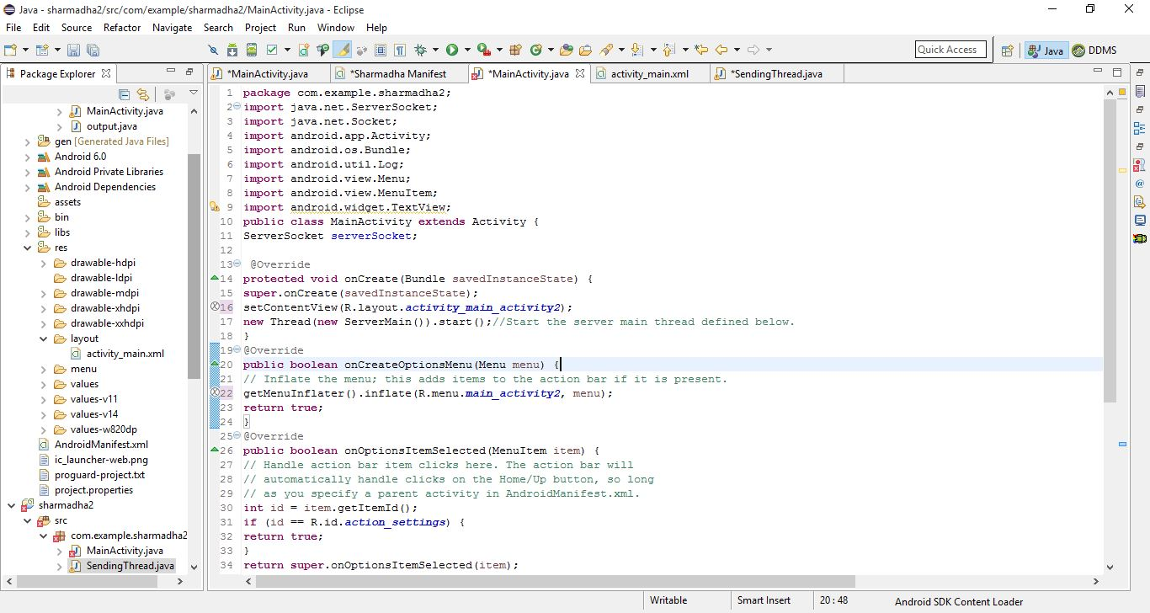

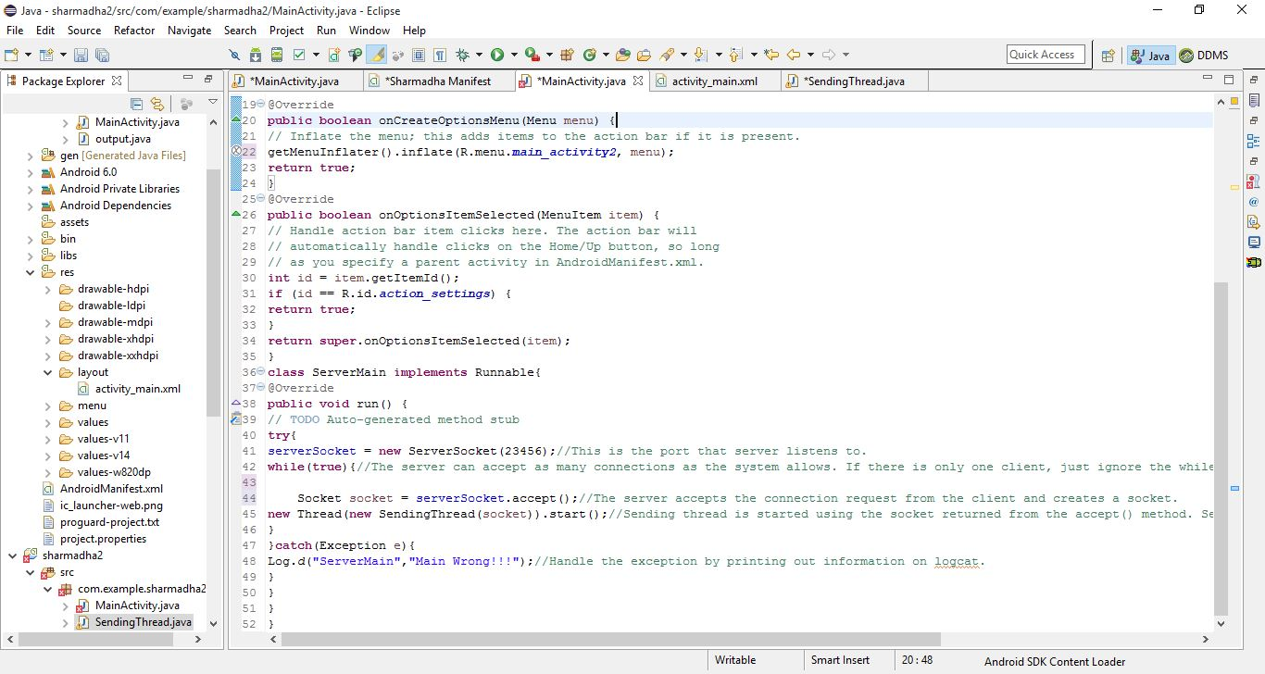

SENDING THREAD:

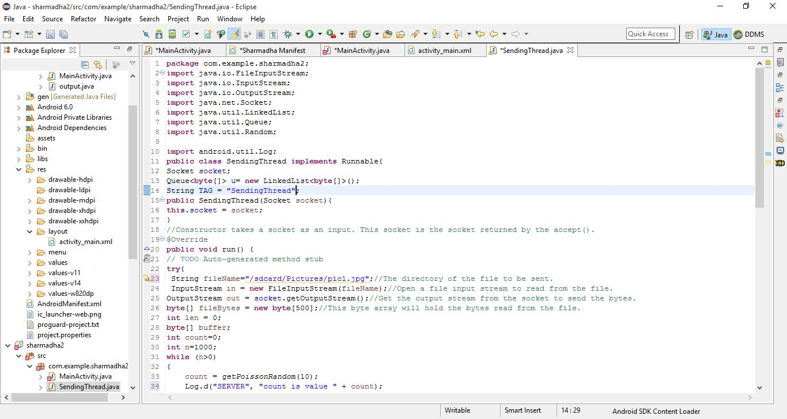

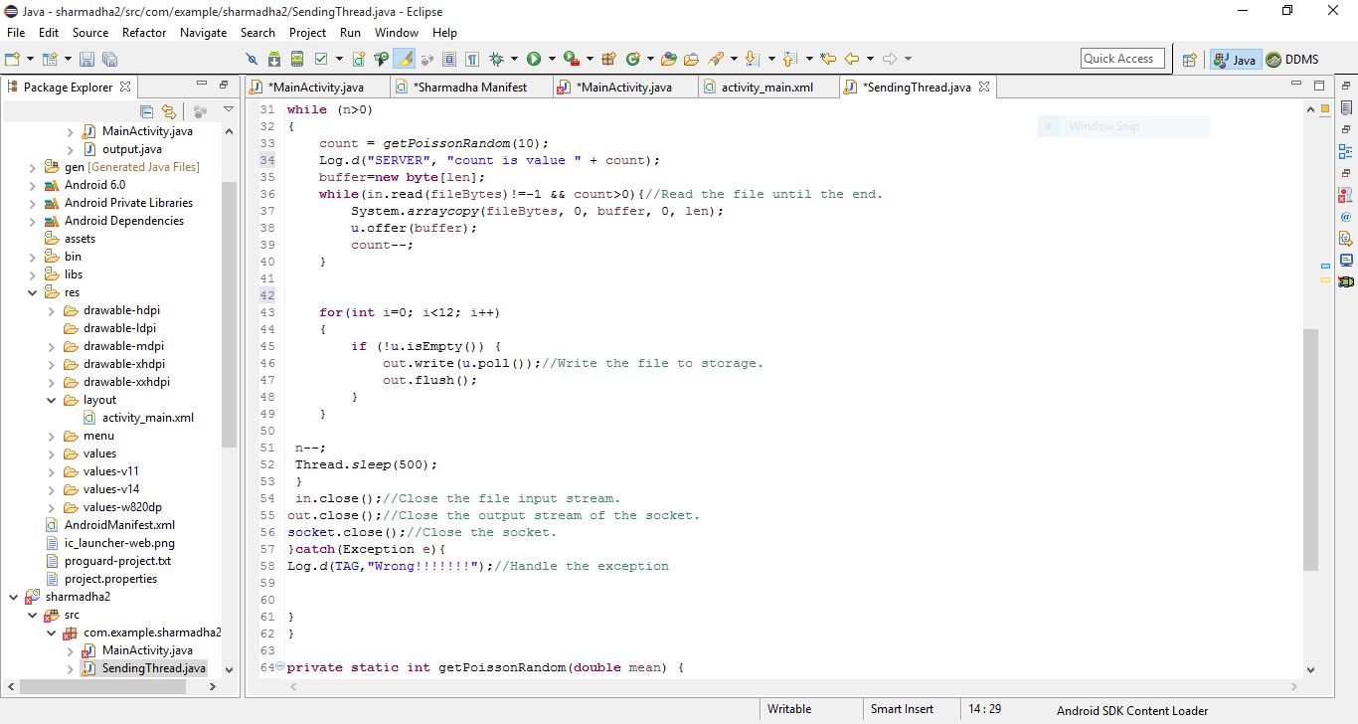

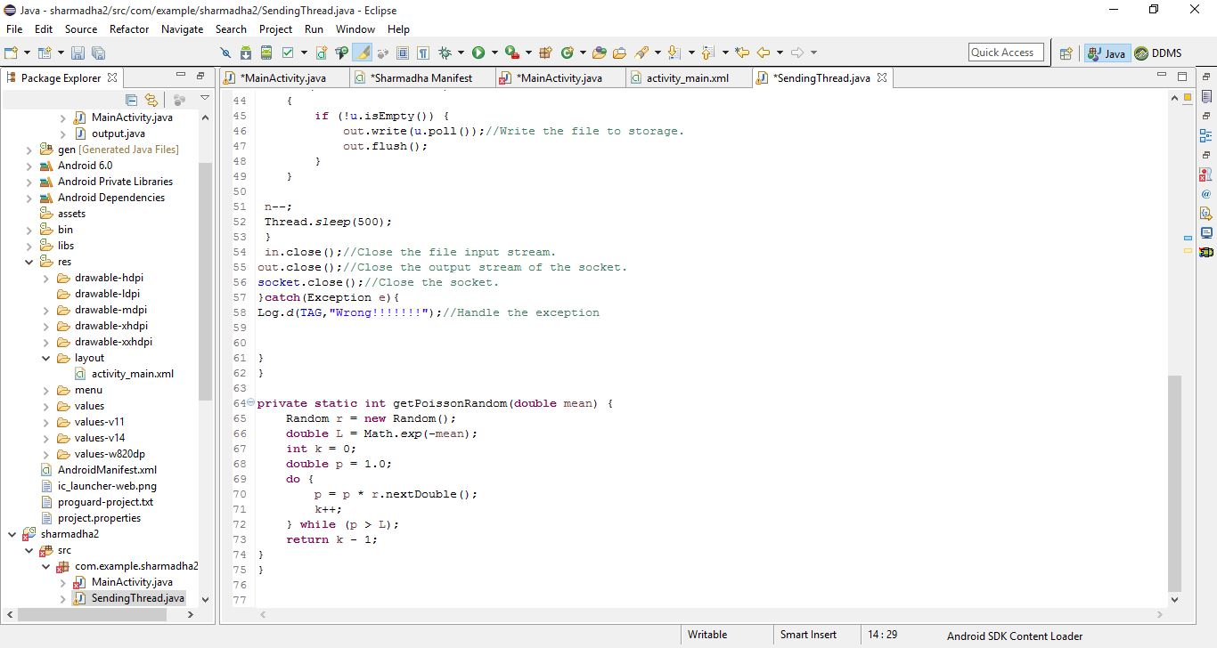

CLIENT RECIEVER (Main Activity):

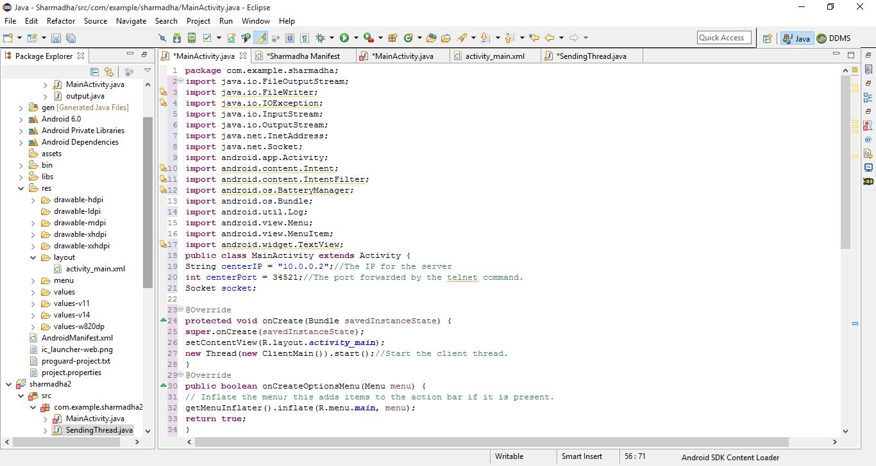

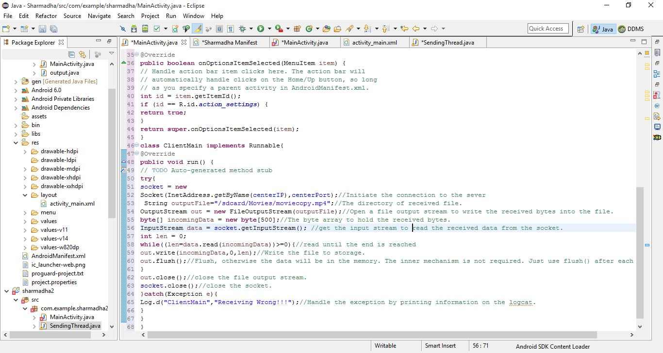

LOGCAT RESULTS

